

CBMS/NSF, Regional Research Conference
in Mathematical Sciences:
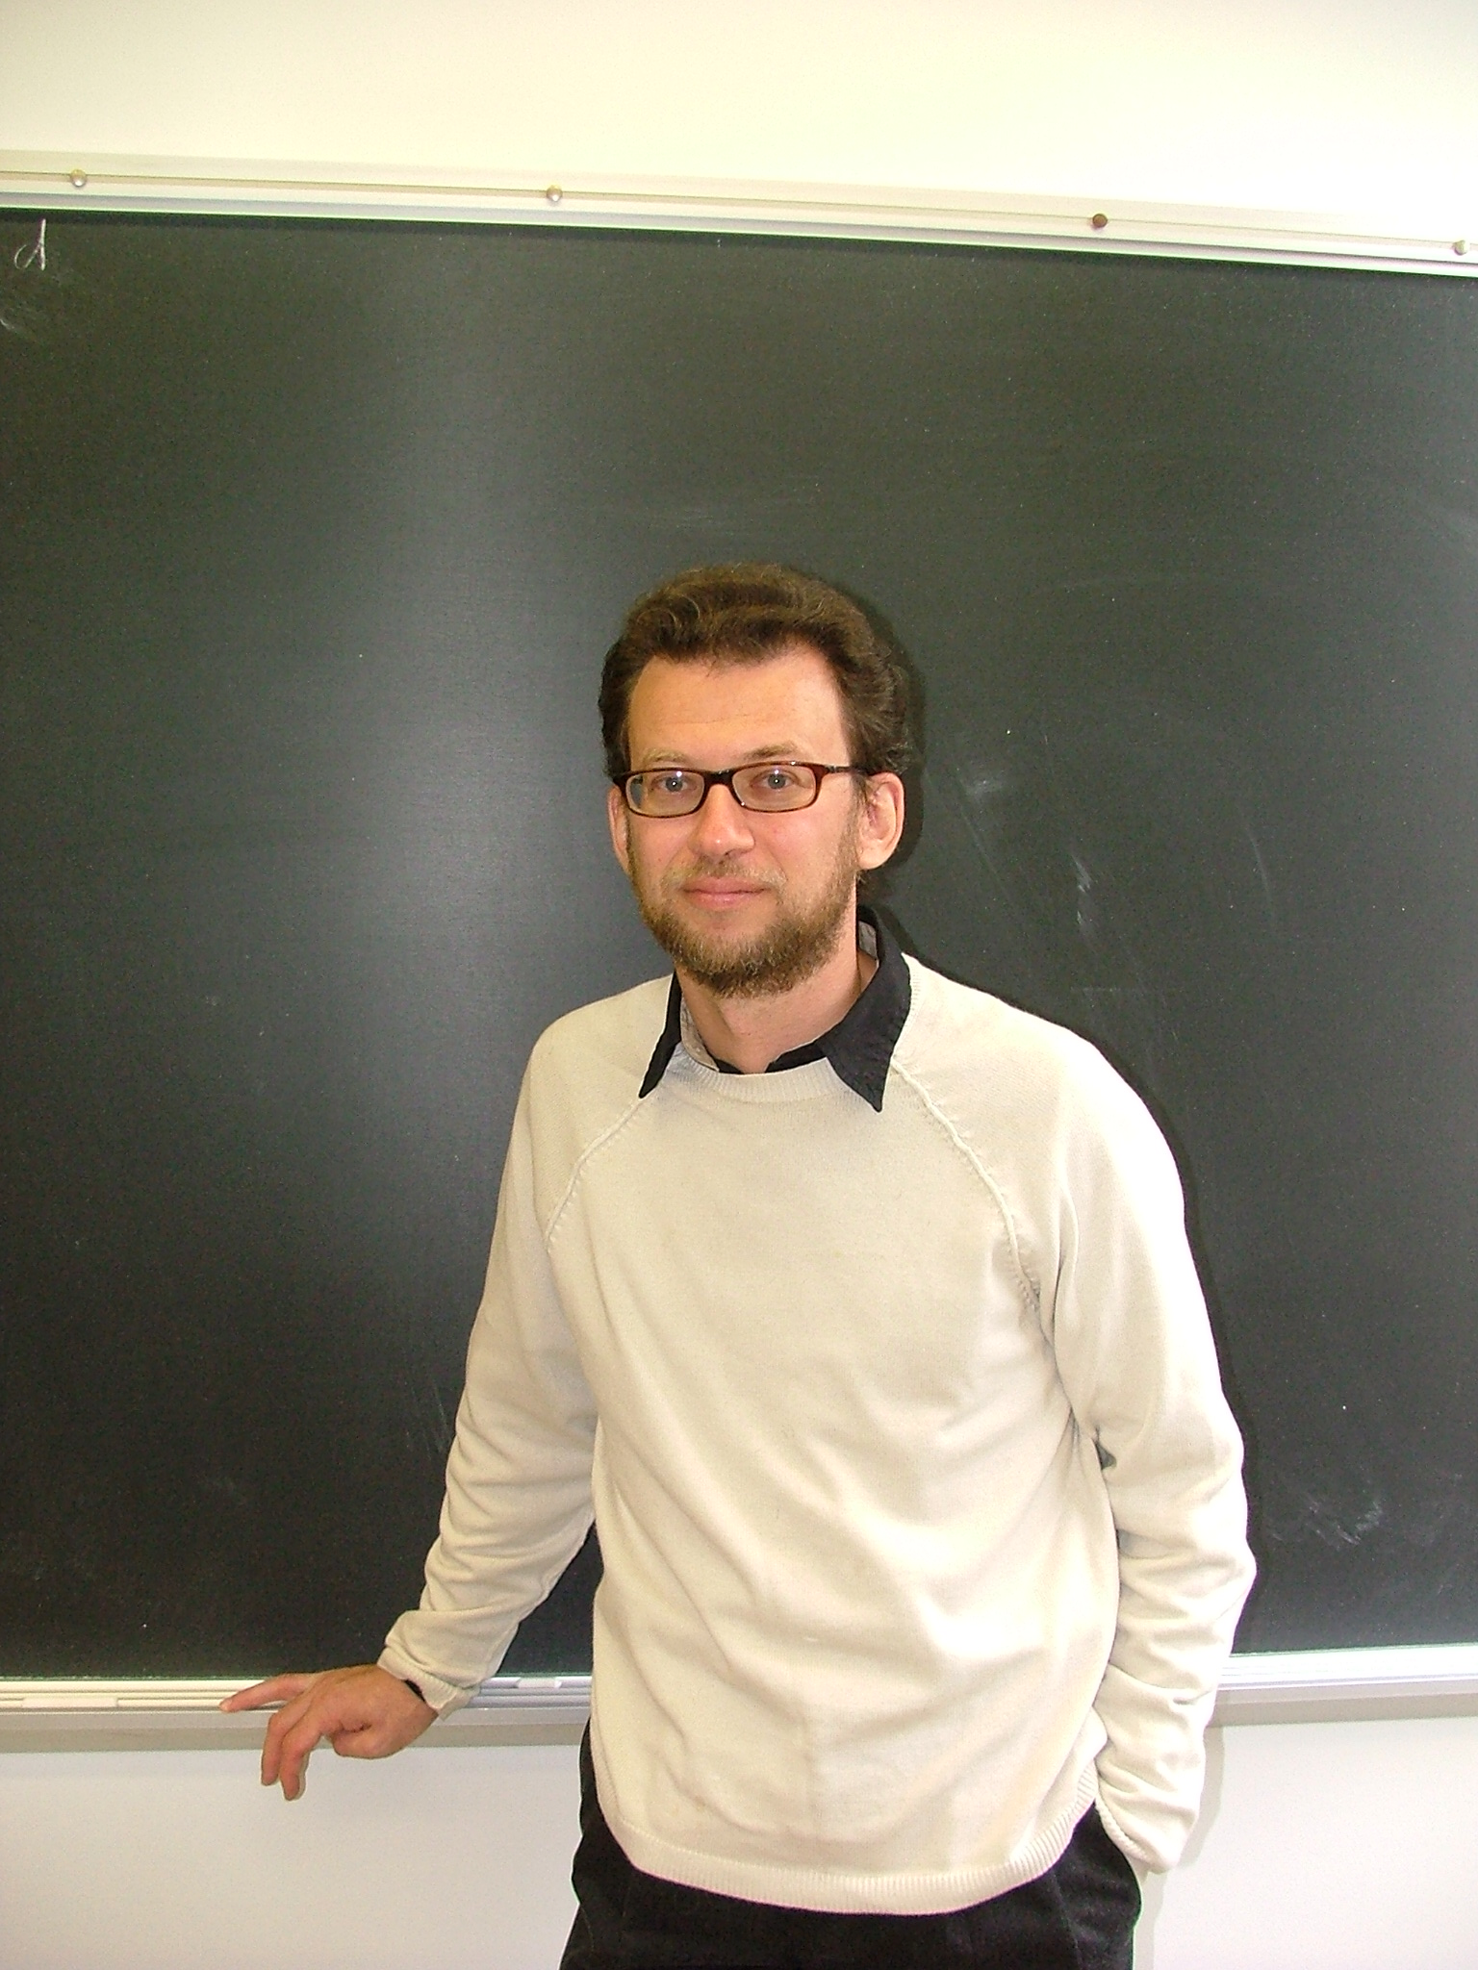
Probabilistic and Combinatorial Approach in Analysis
August 6-12, 2006
Lecturer: Professor Mark Rudelson, University of Missouri-Columbia
Organizers: Richard Aron, Per Enflo, Joe Diestel, Victor Lomonosov, Andrew Tonge and Artem Zvavitch.
The tentative lecture titles:
- Entropy and the supremum of a random process.
- Application of random processes to geometry and harmonic analysis.
- Combinatorial structure of subsets of a discrete cube.
- Approximation of a convex body by parallelepipeds.
- Combinatorial dimension and its connection to random processes.
- Covering Conjecture and separating trees.
- Dimension reduction.
- Entropy versus combinatorial dimension.
- Applications of combinatorial dimension to functional analysis and convexity.
- Convexity and the combinatorial dimension.

With CBMS/NSF funding will be able to cover local expenses for most participants. Housing is available in single/double modern dormitory rooms just a few minutes walk from the department.

Professor Rudelson’s lectures are scheduled from August 6 at 11:00AM until August 10 at 4pm. You may check in to your room as early as August 5.
On August 11-12 there will be additional lectures by participants. We welcome all of you to submit an abstract and title via e-mail as soon as possible. The check-out date for the dormitory rooms is August 13.

More information can be found on http://www.math.kent.edu/math/CBMS.cfm

Please contact Artem Zvavitch zvavitch@math.kent.edu for more information.

